

Ecommerce Website

Belmanufacturing

Khaoula Touati | SquareSpace | 2019

# Link

<https://khaoula-t-bel.squarespace.com>

## Credentials

khawla@starzelectronics.com/ BelManufacturing2019

## About

Ecommerce website developed using square space for Bel Manufacturing



Figure : Home Page

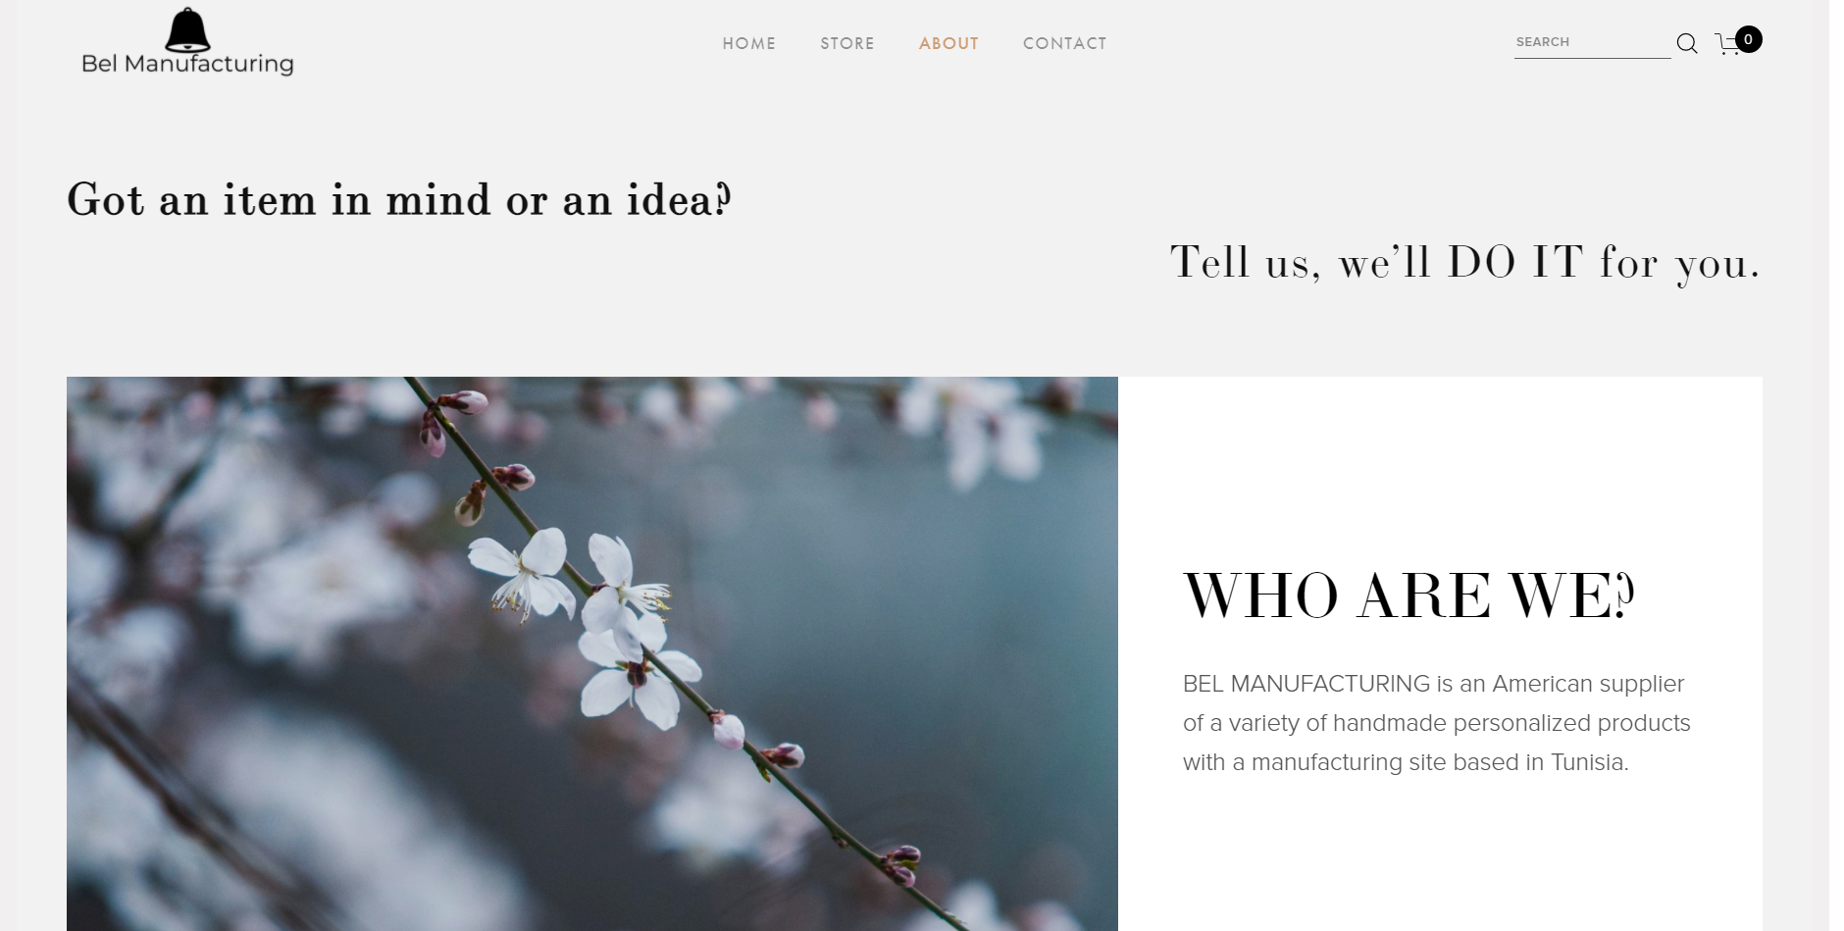

Figure : About

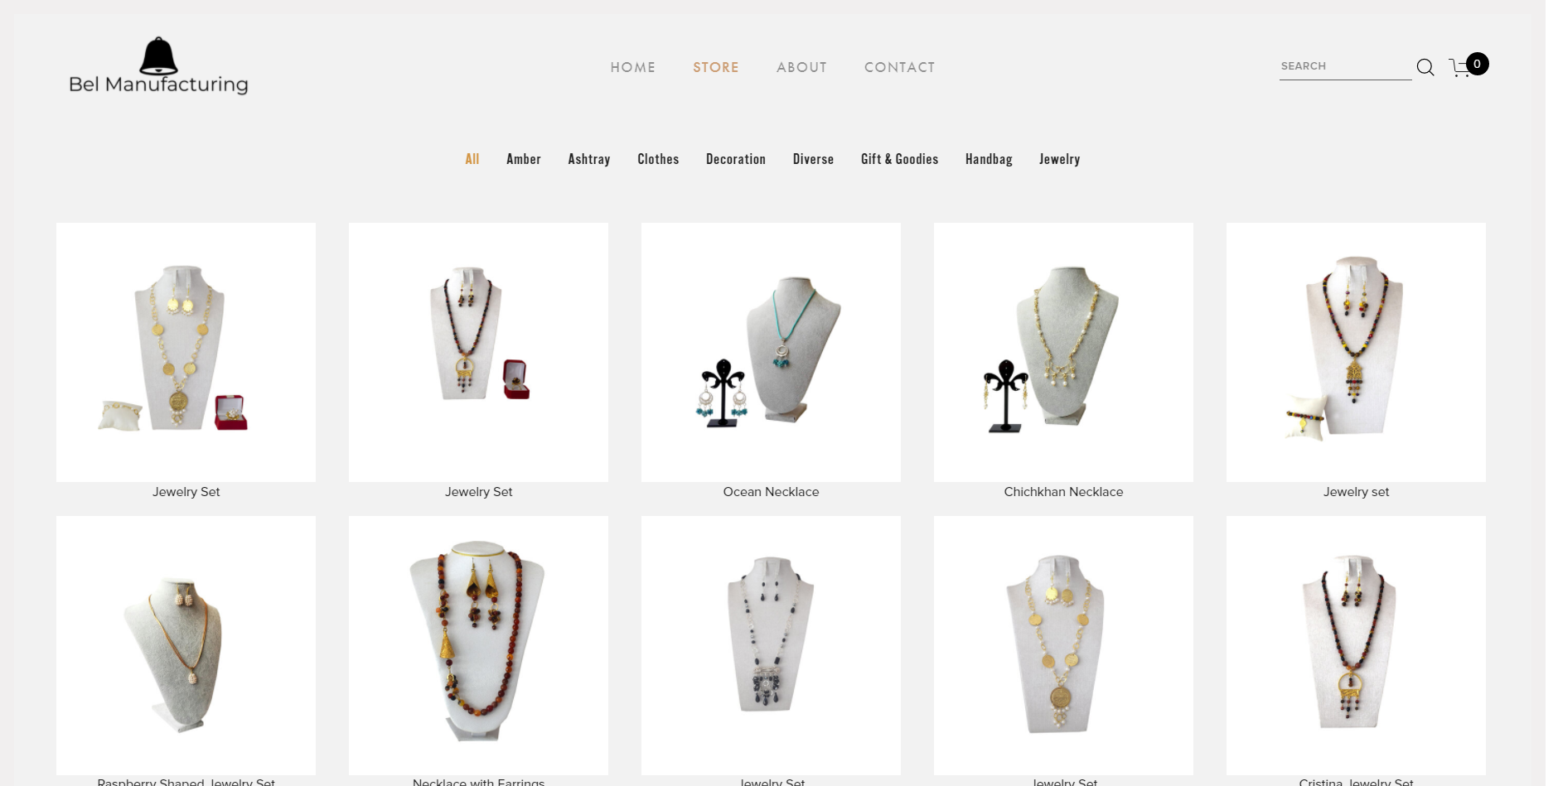

Figure : Store

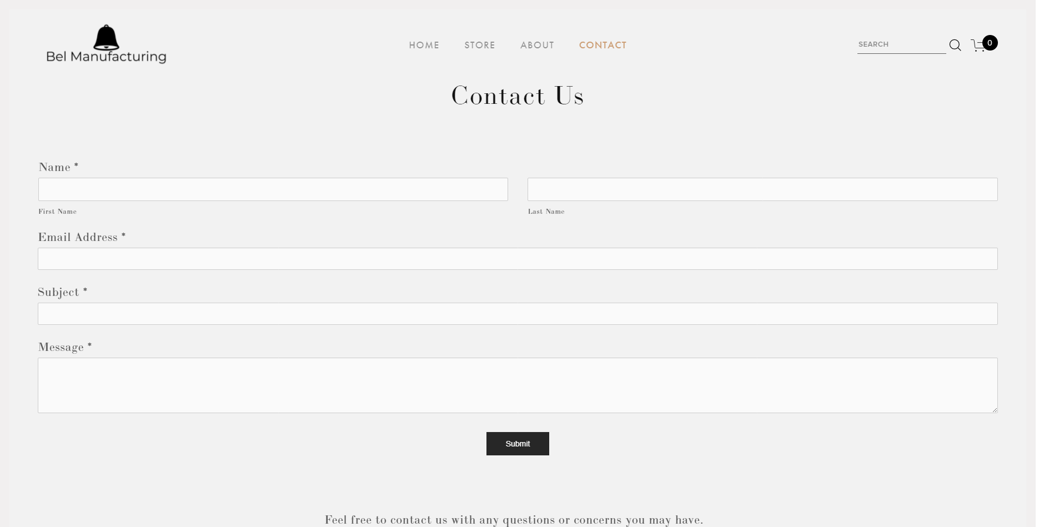

Figure : Contact

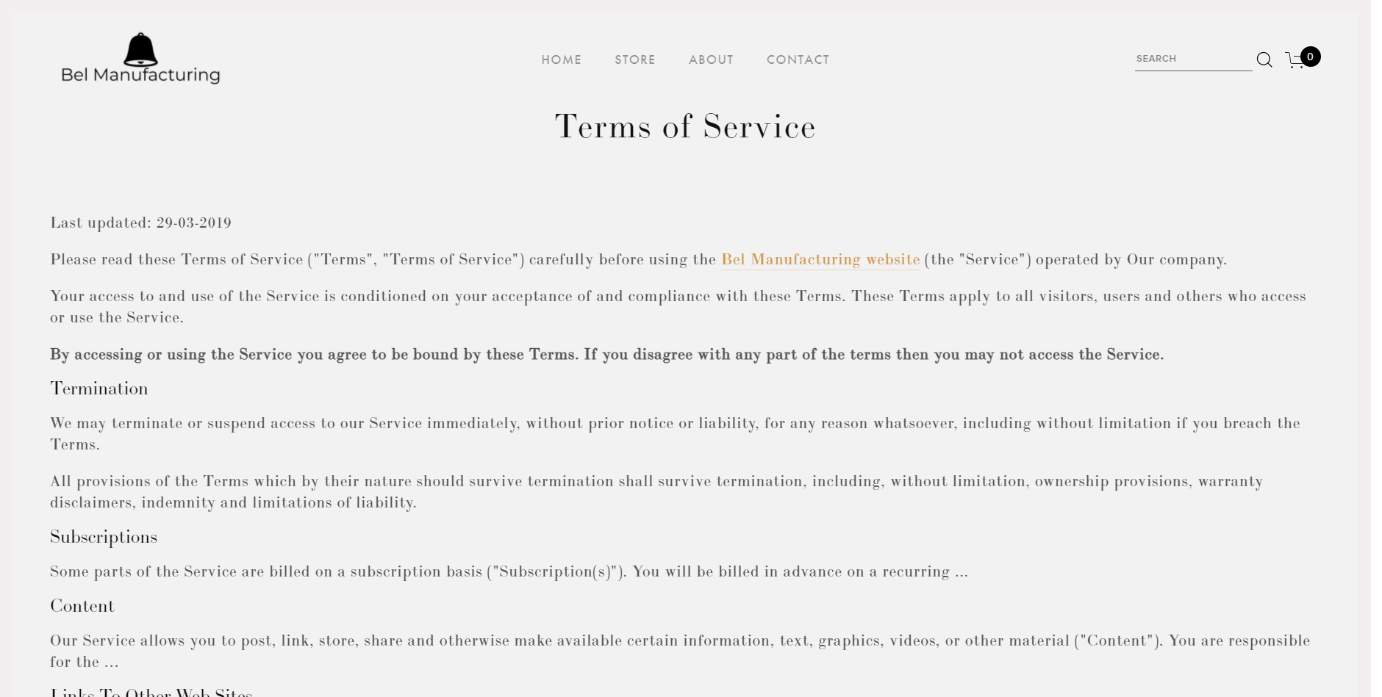

Figure : Terms of Service

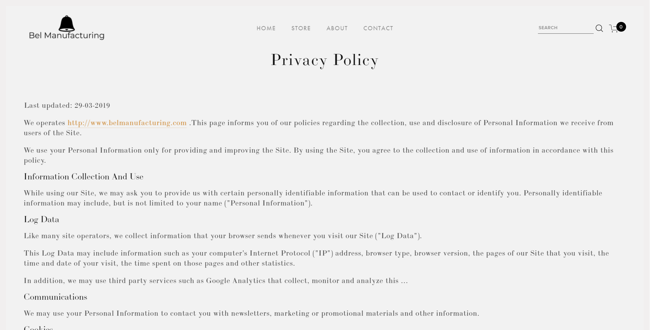

Figure : Privacy Policy